30) Aim: To Draw a Deterministic Finite Automata for the language accepting strings ending with ’01’ over input alphabets ∑ = {0, 1}.

Diagram:

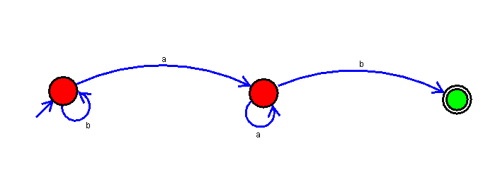

Result:

Successfully executed Deterministic Finite Automata for the language accepting strings ending with ’01’ over input alphabets ∑ = {0, 1}.